AATC_Monitor_Viewer
The AATC_Monitor_Viewer module allows a visual representation of the current air space for a given server. The program displays the drone, flight waypoints, flight start and end points and NoFlyZones at their current location with information about the item displayed as text next to the item if close enough. The program uses pygame to display the objects.
Note: Framerate is generally high at around 30-60 fps at 2000 items on screen, however a high framerate was not the target of this program as it is designed to be a static display, updating every 60 seconds per default.

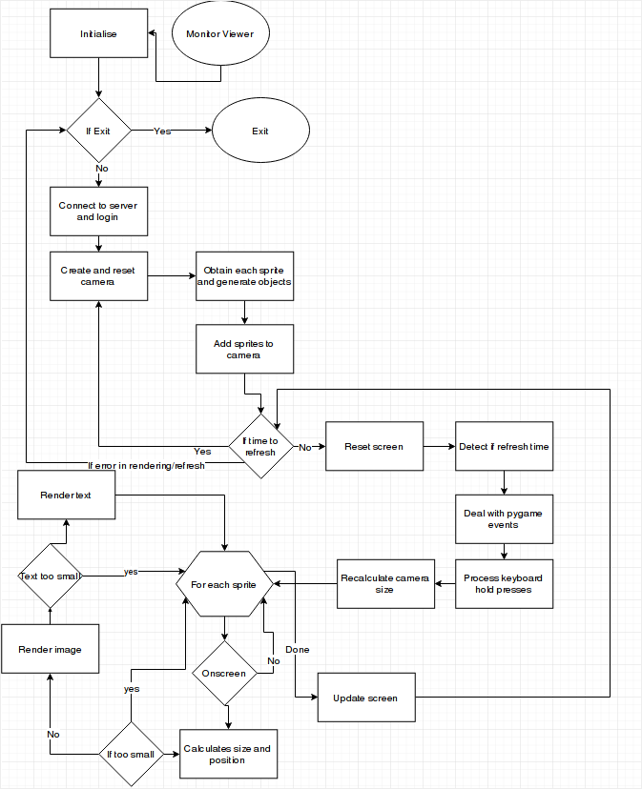

Pseudocode:
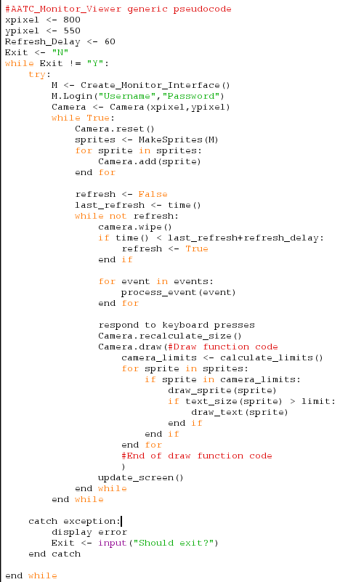

HCI
The monitor viewer is used to display the drones, flights, flight waypoints and NoFlyZones as an interactive display which allows a person to zoom in and out and pan across the display area. This can be used to provide a visual display for any clients e.g. as an infographic of the density of drones in certain areas or to monitor ( hence the name) the locations of drones. The monitor shows the values as following:
Grey → NoFlyZone
Green → Flight waypoint
Blue → Flight start
Red → Flight End
White → Drone

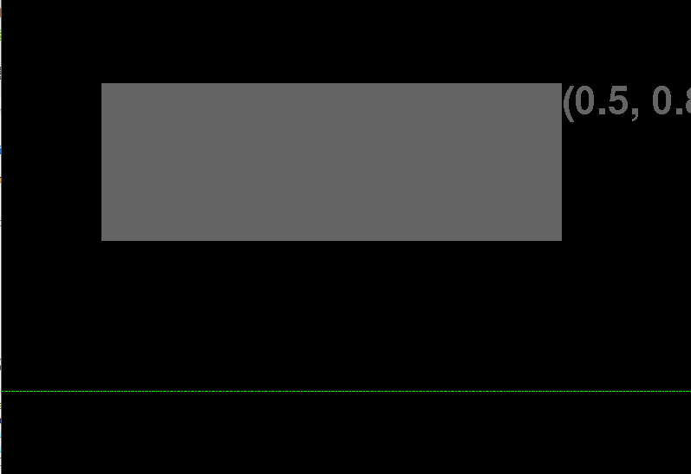
Additionally text will be displayed next to the object with details about the object such as coordinates , level, name, owner etc. WASD is used to pan and Q/E to zoom. Finally using a mouse button will display information about the current display e.g. number of items , current coordinates, zoom level.

Import

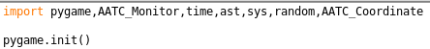
The program imports a number of modules, pygame is required to display the object. AATC_Monitor is used to access the monitor API. Time is used to manage the framerate independent movement. Ast is used to convert the columns of the queries into python lists. Sys is required for the exit functionality, random is required to randomly remove items from the cache if the cache is full. AATC_Coordinate is used to represent coordinate data as an object.
Pygame.init is used to initialise the pygame module.

Caches
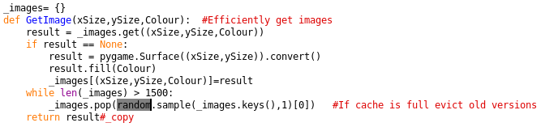
As the program will be rendering thousands of identical items it is possible to cache the rendered items and therefore speed up the program. The GetImage function is used to cache rendered surfaces by storing them in the _images dictionary. The function takes the x and y sizes of the surface as well as the colour tuple of the surface. The program then checks if such a surface is in the database, if it not the program will create a new pygame surface of that size , fill it with that colour and place the result into the _image dictionary for later use. The program also checks that the cache has less than 1500 items in it in order to lower memory usage, if there are too many items a random item is selected and removed until there are 1500 items or less in the cache. (Random sampling is used as selecting the first or last item out of a dictionary will keep evicting the same surface if it is commonly used leading to a decrease in performance, this random method only causes a given surface to be evicted infrequently). Finally the program returns the result

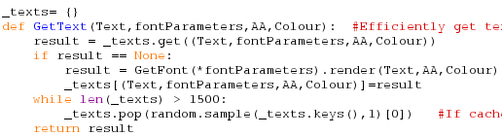
The GetText function is very similar to the GetImage function. This program is used to obtain rendered texts and to cache these texts. The function takes the string text, tuple font parameters , boolean AA (antialiasing flag) and tuple colour. The program attempts to search for the given item in the cache _texts dicitonary, if it not found a font is obtained using the GetFont function and fontParameters and used to render the text according to the parameters. The result is then placed into the dictionary for later use. Should the cache be too large random items will be evicted. Finally the result is returned.

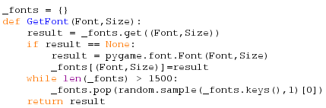
The GetFont function is similar to the GetImage function. This version however caches font object for later use, taking the font and font size as arguments. Should the font not be in the cache it will be created using the pygame font module and added to the _fonts cache. The result is then returned.

General
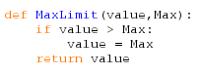
The MaxLimit function limits a function to a maximum.

Camera
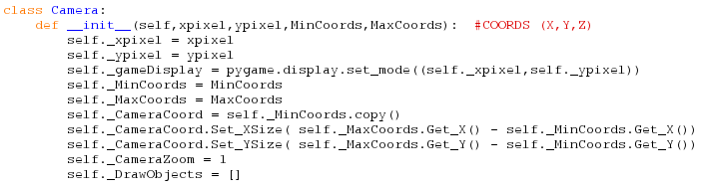
The camera object is the main object used by the Viewer. The camera acts as a frame, keeping track of the current viewable area , the current zoom level as well as the objects which should be drawn. The object takes the x and y pixel sizes of the desired screen as well as the initial Minimum and maximum allowed coordinates which define which area is intially displayed ( no limit on the viewable area).
The relevant parameters are set as attributes. A display surface is created using the defined x and y pixel sizes which will be the screen on which the objects are displayed. The camera coordinate is set to the copy of the minimum coordinate and the camera dimensions in x and y are set to the difference between the maximum and minimum coordinates. Finally the DrawObjects list is added (stores the objects to be drawn) and the zoom is set to the default of 1.

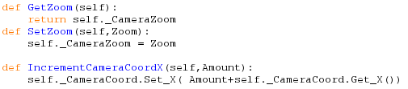
The GetZoom method returns the current zoom of the camera.
The SetZoom method sets the zoom of the camera.
The Increment Camera coord X method increases the camera X coordinate by the amount passed.

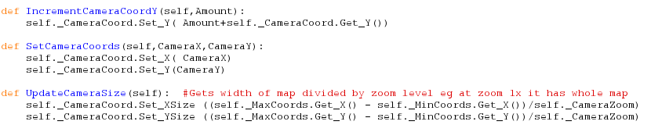
The IncrementCameraCoord Y method increase the y coordinate of the camera by amount.
The SetCameraCoords method sets the camera coordinates to specific values.
The UpdateCameraSize method sets the size of the camera coord based off the current difference between the max and min coordinates divided by the camera zoom (1x zoom is equal to the area between the max and min coordinates, 2x means half the length on each axis).

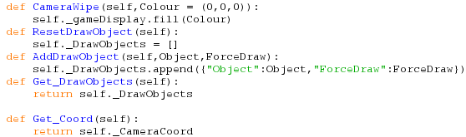
The CameraWipe method fills the screen with the passed optional colour tuple.
The ResetDrawObjects method is used to remove all objects from the DrawObjects list.
The AddDrawObjects method is used to add an object to the DrawObjects so that it may be drawn on screen. The object is passed and the currently unused boolean variable ForceDraw are placed into the list as a dictionary.
The Get_DrawObjects method is used to obtain the entire DrawObjects list.
The Get_Coord method is used to obtain the coordinate object of the camera.

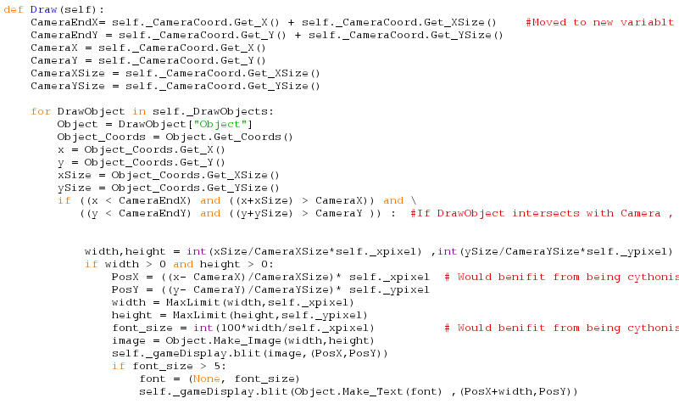
The draw method is used to draw all of the objects onto the screen. The program precalculates the CameraEnd coordinates, obtains the Camera coordiantes seperately as well as the camera size. These calculations are done outside the loop to reduce the number of unnecessary calculations inside the loop (which would be repeated a very large number of times, leading to a noticable performance deficit).
The program then loops through each object in the draw objects list, obtaining the object from the dictionary ( the ForceDraw item is not used currently but could be used to allow only certain types of object to be drawn). The objects coordiantes are obtained and the values extracted. Again they are removed once into variables to reduce overhead from calling the function. The if statement then checks if the object is visible ( is on screen) by comparing the coordinates of each pair of opposite side coordiantes between the Object and the camera screen area. The first and second comparisons are satisfied by the first diagram but the second diagram would fail the second comparison. (The statement effectively checks if the rectangles of camera and object intersect).

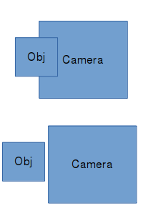
Should the object intersect with the camera then the dimensions of the object in pixels are calculated by comparing the ratio between the object width and that of the current camera and multiplying this by the number of pixels in that dimension ( object is half the size of the current camera it will take up half the screen). Should both dimensions be greater than 0 (at least a 1x1 surface) then the position in pixels is calculated by finding how far across the camera area the object stretches and multiplying this by the number of pixels in this dimension. The program then limits the maximum size in pixels the item can have to the dimensions of the screen ( this prevents a very large item eg no fly zone suddenly coming into view at a high zoom level, creating a very large surface and either crashing pygame or causing a very large surface to be created causing the program to run out of memory. The font size is then calculated and the object surface is created and displayed at the calculated coordiantes. If the font size is large enough the program will render the font required and display it next to the object onscreen , the limit in font size being required to prevent the program attempting to draw 1000+ text object every frame making everything unreadable.

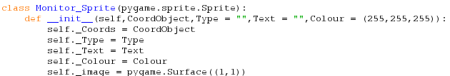
The Monitor_Sprite object is used to store information about a given object the monitor must represent. The object stores details about the obtained object such as type, text and coordinate. The object requires the coordinate object and optionally takes the type ,text and colour of the object. These can be configured on a per instance basis. The relevant items are stored and an initial image attribute is created in the form of a 1x1 surface. The _Image attribute stores the current sprite surface.

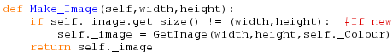
The Make_Image method is used to obtain the surface for the object for the given width and height. The program first checks that the sizes are different to the current image, if they are not the object will assume it may use the current image as the zoom level has not changed. If the size has changed a new image is created using the GetImage function with the desired width ,height and colour. Finally the image is returned.

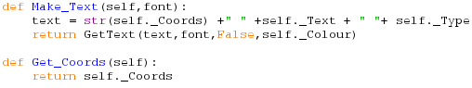
The Make_Text method is used to create the rendered text surface for the object. The method takes a font containing a tuple of (font,font_size) and forms a string containing key details about the object :coordinates , text and type of object. This string is then passed to the GetText function with the font and colour values, forming a rendered text surface.
The Get_Coords method returns the coordinates of the object.

Make_X_Sprites
The following functions are used to create sprites of a given type from an input message and data list. The inputs are from the AATC_Monitor queries to the server, the message contains the column headings in order and the data object contains a the individual lines of data. The function uses the message column data in order to index the given column for each component, providing a way independent of the server column orderings to obtain the correct data. The relevant components are obtained e.g. coordiantes , Ids, names etc and are added to the string Text with a leading indicator such as “U:” for UserID. Each type of object has a different colour and an object is created using all the obtained attributes and added to the X_List where X is the type.
Note: The size of the objects is defined as 0.001 degrees if the object does not have size of it's own. This is much larger than any such object could be, it is placed this way to improve visibility and reduce the need for excessive zooming.
As each function is very similar only the difference to the above method will be described.

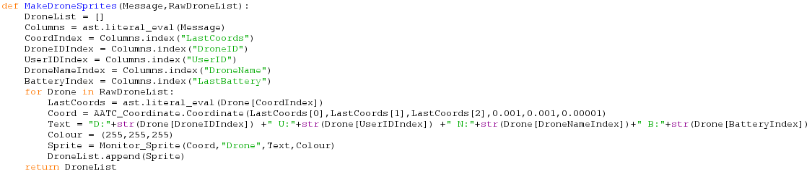
MakeDroneSprites has no deviating components.

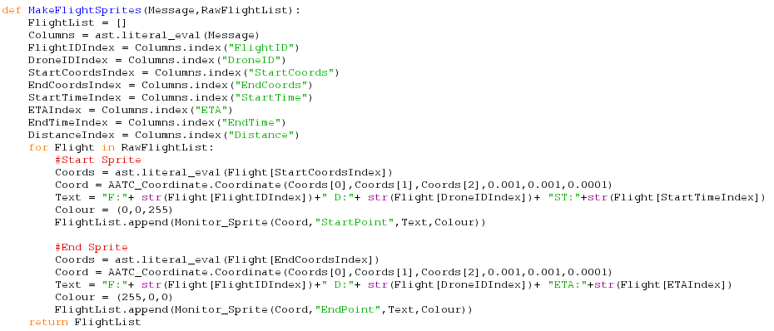
MakeFlightSprites creates both start and end flight sprites. The start sprite has the Start time in the text and a blue colour while the end sprite has the ETA time in the text and a red colour.

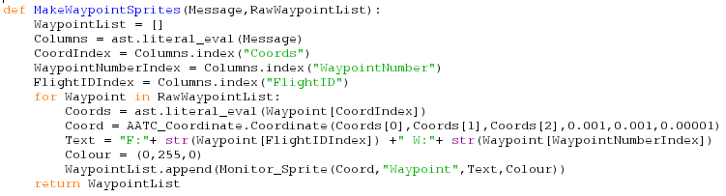
The MakeWaypoints sprite function has no deviating components.

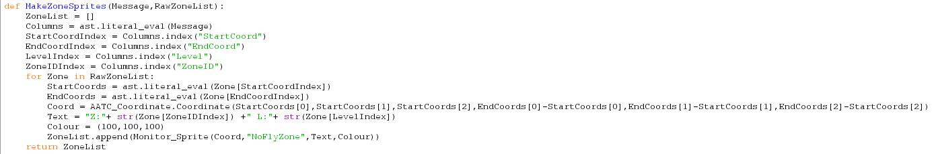
The MakeNoFlyZones function creates coordinates with the size of the NoFlyZone's actual area instead of the default 0.001 size.

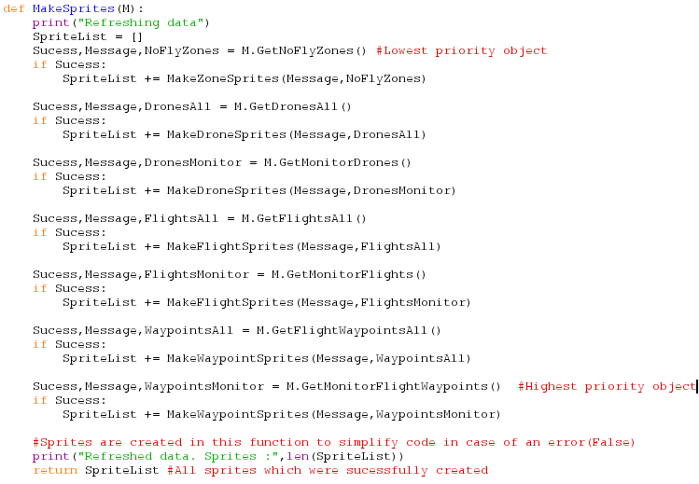
The MakeSprites function is used to assemble a list of monitor_sprite objects from the server. The function takes the Monitor_Interface object M as an argument. The program obtains the Success, Message and Data for each command, if the success is True ( the request did not fail) it then creates the sprites using the relevant function and adds the values to the sprite list. This list then includes all the available Drone, Flights, Flight waypoints and NoFlyZones.
Note: The order in which the requests are handled sets their rendering priority. The objects added last are also drawn last hence over all other objects. Therefore if one wants one type of object to draw over another, add the first object after the second.
Finally the sprite list is returned.

TimeWarper
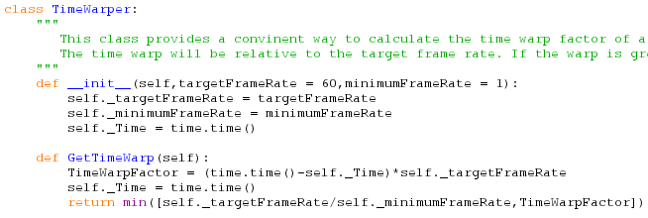
The TimeWarper object is used to disconnect the interaction speed of the Viewer from the frame rate. If a framerate bound program has a dip in the frame rate the entire movement system will also slow down, if the framerate is much higher than expected then the program will act very quickly. This change in movement (i.e. moving camera around) speed may cause issues for the user as for a low framerate system the process of zooming may take 10x longer than usual if the framerate is 6fps.
The TimeWarper object allows a factor to be calculated by how much the system should alter the movement speed, resulting in the same movement speed regardless of the framerate. The object takes the target framerate as well as the minimum framerate as arguments and sets them as attributes. Additionally the time attribute is set, recording the last time the GetTimeWarp was obtained, a reference point on how long the last frame took. The program calculates the time warp factor by calculating the time for the last frame and multiplying this by the target framerate ( if the target frame rate is held dT should be 1/framerate, leading to a time warp factor of 1, if dT = 2*wanted dT then the warp factor is 2). The Time attribute is reset and the program returns the minimum of the target framerate over minimum framerate and the timewarp factor, this minimum prevents massive WarpFactors from occuring (i.e. a 1 second freeze could cause the system to move 60 times the normal distance, which would be unexpected).

Main

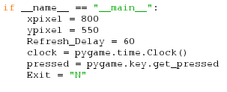
If the program is not imported the program will create the default parameters of the program. This includes the dimensions of the screen, the time between refreshes , initialising a clock , defining the pressed variable and setting Exit to “N”. The clock is required for the framerate and pressed is used to detect if a key is pressed.

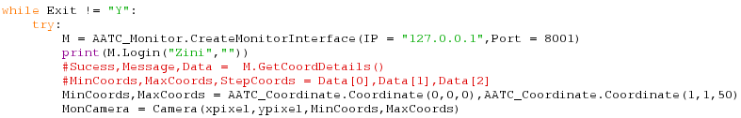
The program then enters a while loop which will only exit once Exit is set to “Y”. The monitor interface object is created ( the default parameters are set to localhost and the monitor port). The program will then attempt to login using the credentials passed as parameters ( defaults shown, will have to be changed. In order to login replace the shown values with your username and password, using the MonitorInterface to add a Monitor if needed.). The program does not ask for a username or password as the monitor interface is supposed to be a program which runs constantly, updating the locations of all objects on a screen, in order to do this the program most likely will be launched by a script which will not enter a username and password. Furthermore the credentials of a user will not change frequently , therefore they can be saved in the program rather than querying them each time.
The Min and MaxCoordinates are defined, representing the default area over which the monitor will render ( 0 ->1 chosen as that is the size of the graph used and as such no objects will be outside this area per default. Finally the camera object is created using the defined sizes as well as the min and max coordinates.

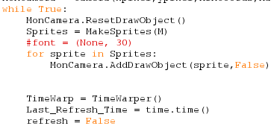
The program will then enter another while loop, this one looping continously until an exception occurs. First the camera is reset , removing all old draw objects. Then the program will obtain all sprites using the MakeSprites function, using this list to add each DrawObject to the camera via the AddDrawObject function ( False flag not used currently). The TimeWarper object is then created and the Last_Refresh_Time ( time at which the program last obtained new data from the server) is set to the current time. Finally the refresh flag is set to false ( this loop occurs once per refresh).

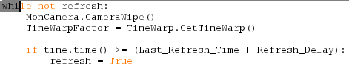
The program then enters a third loop, this one continuing until refresh is set to True. This loop repeats for each frame rendered , therefore the camera is wiped so that the image of the last frame is removed. The time warp factor is then calculated and stored. The program will then check if the current time exceeds or equals the Last_Refresh_Time added to the Refresh delay, signalling that it is time for a refresh of the data from the server, this is done by setting the refresh flag to True.

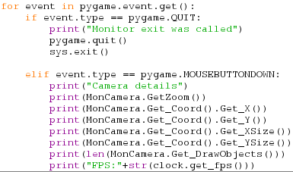
The program then checks the pygame event queue. If a Quit event is found the program will exit, closing the window and calling sys.exit, pygame.quit is used to close the window as the window does not close per default on exit. Should the program find a mouse button click event it will display current information about the camera such as zoom , coordinates , size and number of objects as well as the current frame rate. This feature is mostly for debugging or checking the performance of the system.

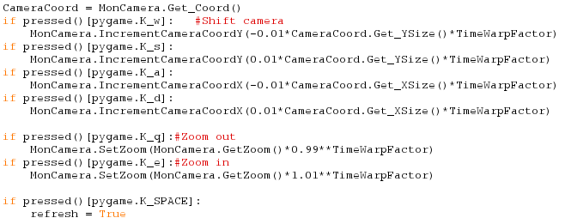
Once all events are processed the program will check for button presses. These are detected using the pressed function which polls the buttons rather than through the event queue. The event queue only detects changes and would require additional boolean variables for every key to keep track if it was pressed or not. The requirement to detect the pressed key is that when scrolling the camera the user should not have to tap the key in order to move but should be able to hold down the key for smooth movement.
The program first obtains the camera coordinate object. This is used with calculations for movement of the camera. Buttons are as follows
W → Decrease Y by 1/100 of the camera's Y size * TimeWarpFactor
S → Increase Y by 1/100 of the camera's Y size * TimeWarpFactor
A → Decrease X by 1/100 of the camera's X size * TimeWarpFactor
D → Increase X by 1/100 of the camera's X size * TimeWarpFactor

Q → Set the zoom to 0.99 to the power of TimeWarpFactor
E → Set the zoom to 1.01 to the power of TimeWarpFactor
Q and E alter the zoom factor by 1% each frame , ^ TimeWarpFactor calculates this effect over the TimeWarpFactor amount of frames. (i.e. if TWF = 2 , then decrease by 1.99%).

Space → Force a refresh. This force the program to update the data from the server immediately.

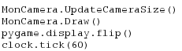
Lastly the program will calculate the new camera size , render each item on the screen, flip the screen in order to display the drawn items. Clock.Tick causes the program to wait however long it takes to cause the frametimes to be 1/60 seconds, and does not wait if 60fps cannot be held in that frame.

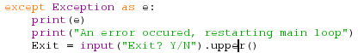
Finally the except statement completes the try/except pair with the try statement in the first while loop. This except statement catches any errors and displays the error to the user. The user is then asked if they want to restart the main loop or not, if Y then the program will restart. If N the program will close.

